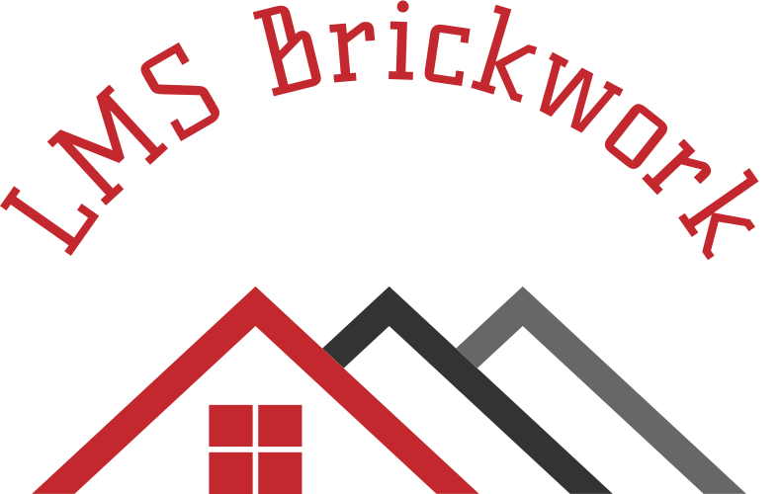
Lmsbrickwork@gmail.com Tel:07776134907

LewisSealey
LMS Brickwork
27 Thorneley rd
Kingsclere
Newbury
Berkshire
Rg20 5rp
25/09/2024

Kingsclere parish counsil

Job to be carried out:

To repoint worse areas of the wall with sand and cement with a stick rubbed finish to blend in with the excising see photos in email

£500.00

Or

To repoint the whole wall in sand and cement with a stick rubbed finish

£1650.00

Thank you for the chance to quote work on your property

I look forward to hearing from you

Lewis Sealey
LMS Brickwork



